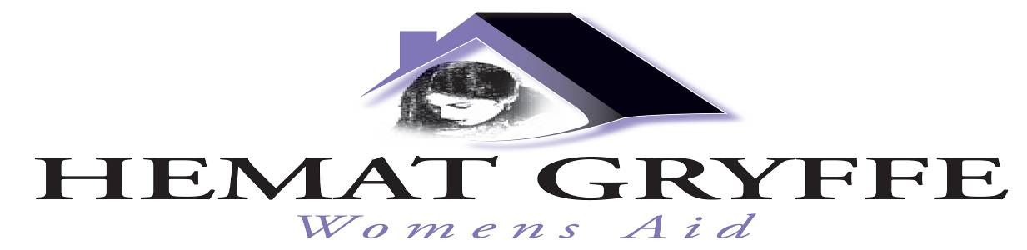

Flat 0/1, 24 Willowbank Street, Charing Cross, Glasgow G3 6LZ
Tel: 0141 353 0859
Email: womensaid@hematgryffe.org.uk Web: www.hematgryffe.org.uk

Vacancy: Women’s Domestic Abuse Community Worker

Hemat Gryffe Women’s Aid is seeking to recruit a women’s worker to provide support to vulnerable women who have experienced domestic abuse.

Hemat Gryffe Women’s Aid supports women, children and young people experiencing domestic abuse, forced marriage and honour-based abuse primarily from the Asian, Black and Minority Ethnic community.

Experience of working with women and knowledge and understanding of the impact of domestic abuse, forced marriage and honour based abuse on women from minority ethnic backgrounds is required.

A suitable qualification that meets the needs of the Scottish Social Servies Council (SSSC) housing support registration is required otherwise training will be provided.

The nature of our work requires a commitment to the feminist analysis of domestic abuse and values of Hemat Gryffe Women’s Aid.

Completed application forms or a Curriculum Vitae (CV) are acceptable (see covering letter for more information).

Application Notes
Salary: £28,500 PA, plus contributory pension.
Hours: 35 hours per week, exclusive of lunch breaks.
Closing Date: Monday 3rd February 2025 at 5pm
Funder: Glasgow City Council Community Fund.

An application pack can be obtained by emailing recruitment@hematgryffe.org.uk or by visiting www.hematgryffe.org.uk.

Please note: Women only need apply (under Schedule 9 (Part 1) of the Equality Act 2010).

